MJMCA Query manual

Basic User Interface #

basic Interface Login

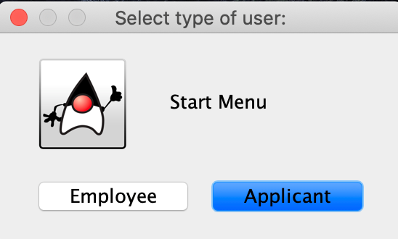 #

Ease of use #

Drop Down menu offers easy selection of data

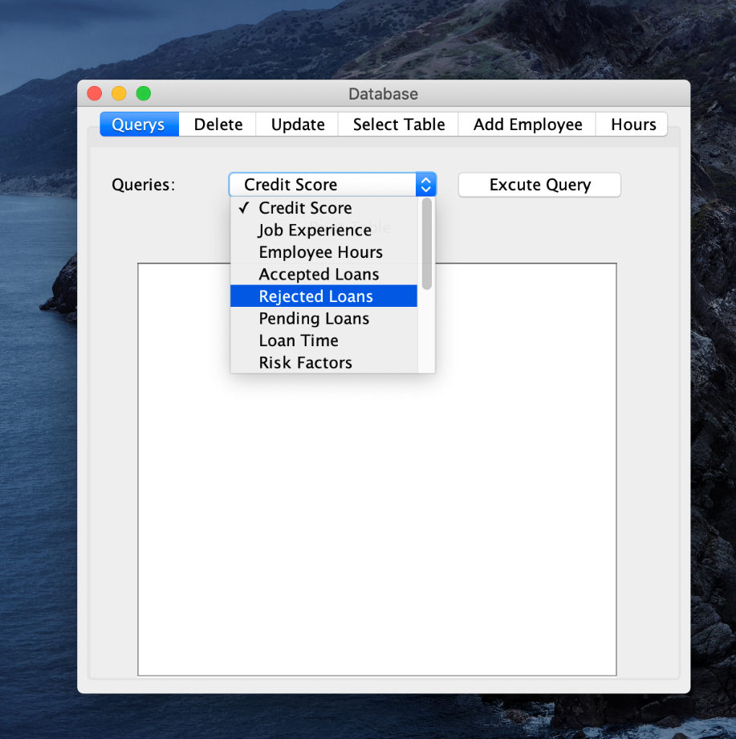 # # #

#

Adding applicants #

multiple input boxes

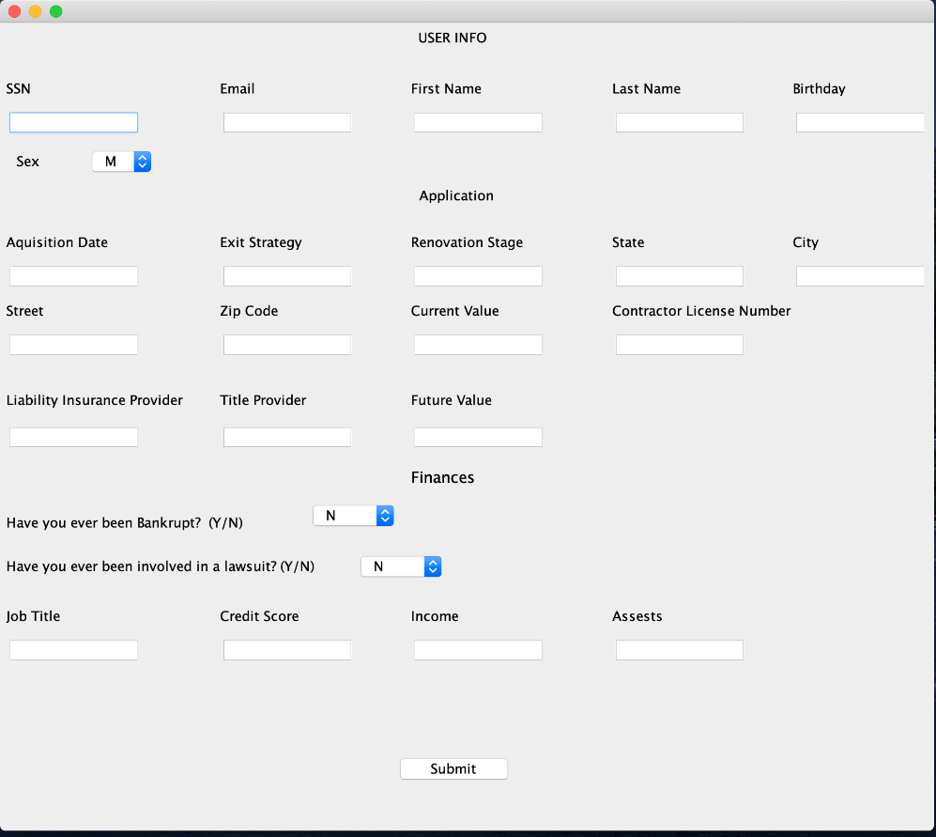 #

certain required fields #

allows for full applicant info integration

Employee Inputs

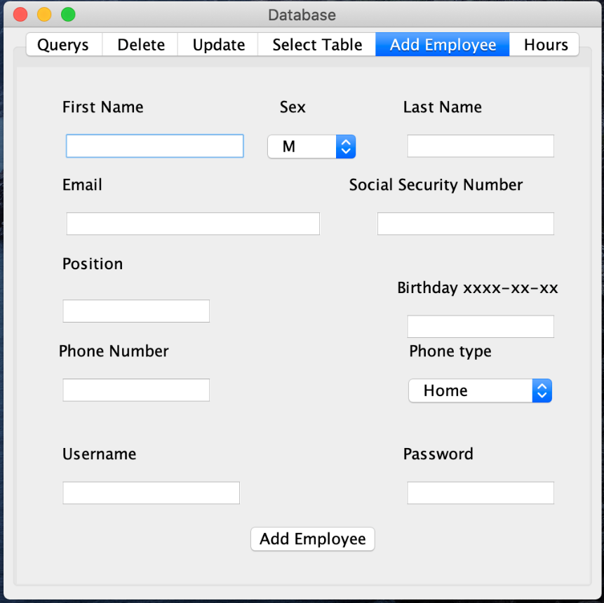

#

individual information can be updated (i.e. update tab) #

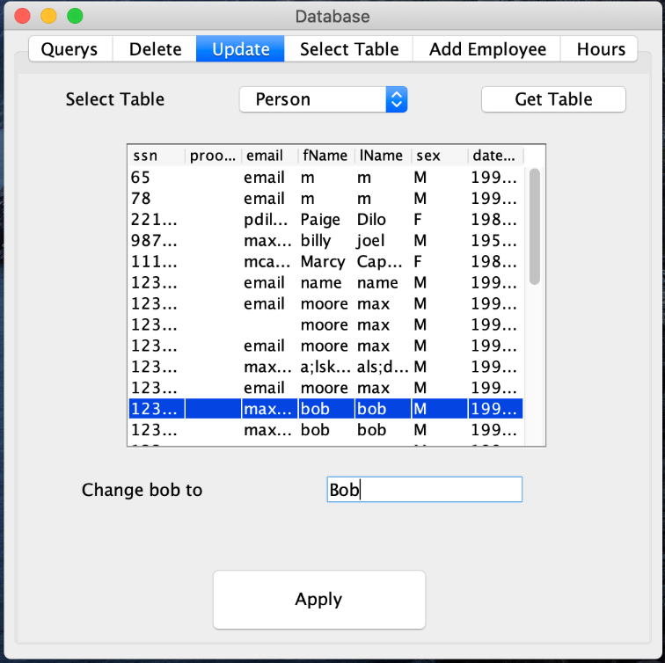

#

individual deletion

 